Image Style Transfer Using Convolutional Neural Network

1. Introduction

In this work we show how the generic feature representations learned by high-performing Convolutional Neural Networks can be used to independently process and manipulate the content and the style of natural images. We introduce *A Neural Algorithm of Artistic Style*, a new algorithm to perform image style transfer.

1. Deep image representations
   1. Content representation

Generally each layer in the network defines a non-linear filter bank whose complexity increases with the position of the layer in the network.

Let ~p and ~x be the original image and the image that is generated, and Pl and Fl their respective feature representation in layer l. We then define the squared-error loss between the two feature representations

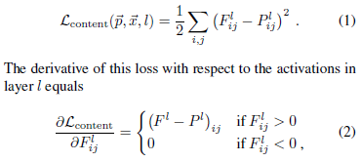

* 1. Style representation

To obtain a representation of the *style* of an input image, we use a feature space designed to capture texture information.

* 1. Style transfer

1. Results

The key finding of this paper is that the representations of content and style in the Convolutional Neural Network are well separable. That is, we can manipulate both representations independently to produce new, perceptually meaningful images. To demonstrate this finding, we generate images that mix the content and style representation from two different source images.

* 1. Tradeoff between content and style matching

Of course, image content and style cannot be completely disentangled. When synthesising an image that combines the content of one image with the style of another, there usually does not exist an image that perfectly matches both constraints at the same time. However, since the loss function we minimise during image synthesis is a linear combination between the loss functions for content and style respectively, we can smoothly regulate the emphasis on either reconstructing the content or the style.

* 1. Effect of different layers of the Convolutional Neural Network

Another important factor in the image synthesis process is the choice of layers to match the content and style representation on.

* 1. Initialisation of gradient descent
  2. Photorealistic style transfer

1. Discussion

Here we demonstrate how to use feature representations from high-performing Convolutional Neural Networks to transfer image style between arbitrary images.